Building At Mahim.

1. Project Information
- Project Name: The Bella Vista
- Location: Mahim.
- Plot Area: 2700 sq.mt.
- Built-up Area: 34027 sq.mt.
- Project Type: High-rise residential and commercial development
- Client/Developer: Transindia Group
- Status: Planning / Approval

2. Project Overview & Design Concept
Bella Vista is a contemporary high-rise residential development designed to create a strong and refined presence within the urban landscape. The development combines well-planned residential towers with commercial spaces at the ground level, creating a lively and active edge to the development.
The architectural design is based on a balance between strong vertical forms and softer curved elements. Clean vertical façade fins emphasize the height of the towers, while curved corner balconies soften the overall massing and add a sense of movement to the façade. Large glazed openings bring natural light into the residences while creating a modern and open appearance.
A restrained white and grey colour palette, combined with darker accents, extensive glazing and integrated greenery, gives the towers a sophisticated contemporary character. Landscaped balcony bands add warmth to the façade and create a visual connection between the residences and the surrounding landscape.
The project extends the living experience beyond the apartments through a range of landscaped and recreational spaces. The rooftop is planned as an active community zone with a jogging track, children's play area, landscaped seating, pergolas and outdoor gathering spaces. Recreational lawns and activity areas provide residents with additional opportunities for relaxation, exercise and social interaction.
Carefully planned pedestrian and vehicular entrances, along with integrated façade and landscape lighting, complete the overall design. Together, the architecture, landscape and recreational spaces create a cohesive residential environment that is modern, comfortable and visually distinctive.

Or
2. Project Overview & Design Concept
Bella Vista is designed in response to the way people live in a dense and fast-growing city like Mumbai, where limited land, high-rise development and a busy urban lifestyle often leave very little space for residents to connect with nature or spend time outdoors.
In a city where homes are increasingly compact and open spaces are limited, the design looks beyond the apartment itself and creates opportunities for residents to step outside, relax, exercise and spend time with family without leaving the building.
This is the main idea behind the rooftop garden and recreational landscape. Instead of treating the roof simply as a service or unused area, it is transformed into an elevated green community space. The rooftop provides a much-needed sense of openness within a dense urban environment, with landscaped gardens, a jogging track, children's play areas, seating spaces, pergolas and recreational lawns.
The architecture combines strong vertical lines with softer curved corners, creating a contemporary and elegant tower form. Large glazed openings, landscaped balcony bands and carefully placed greenery bring a sense of openness and connection with the outdoors.
The rooftop therefore becomes an extension of the residents' living space — a place to breathe, walk, play, relax and interact, offering a small escape from the intensity and compactness of everyday Mumbai life.
Overall, Bella Vista aims to create a balance between high-density urban living and the need for greenery, recreation and community, making the most of every available space within the development.

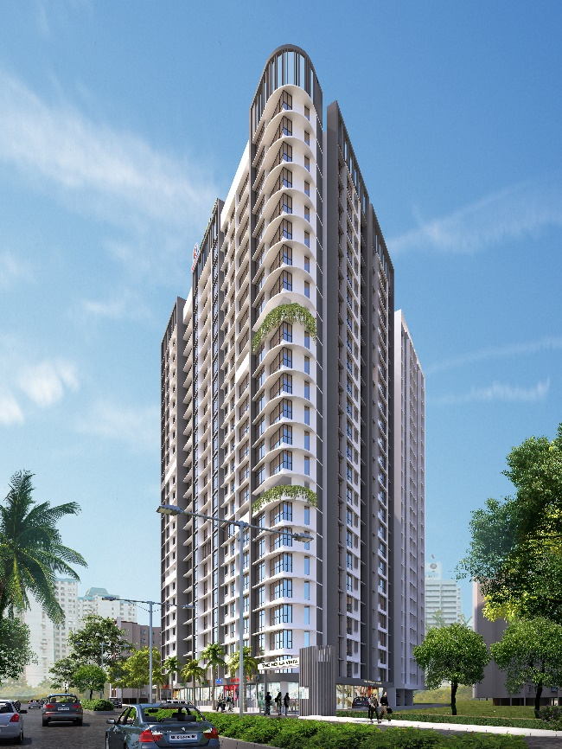
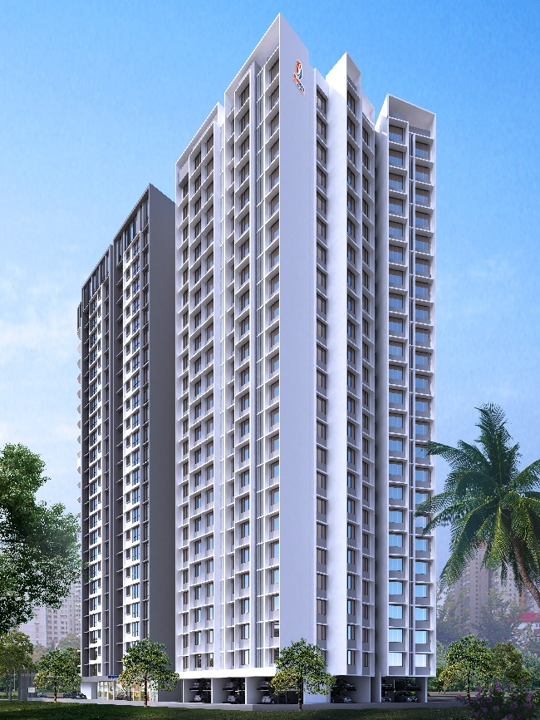
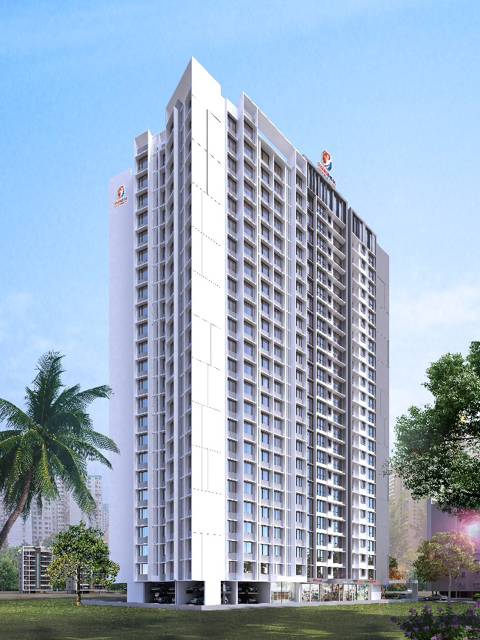
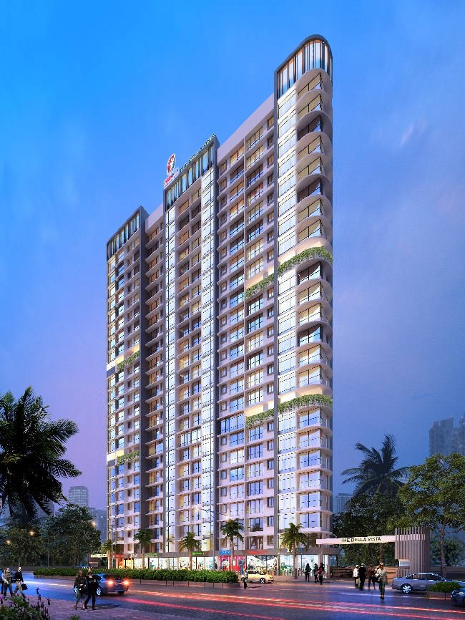
Image 1.
Image 2.
Image 4.
Image 3.
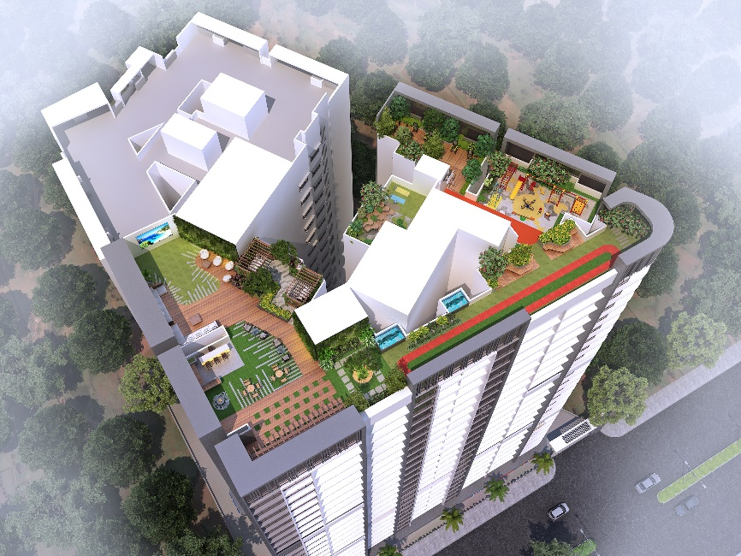
Image 5
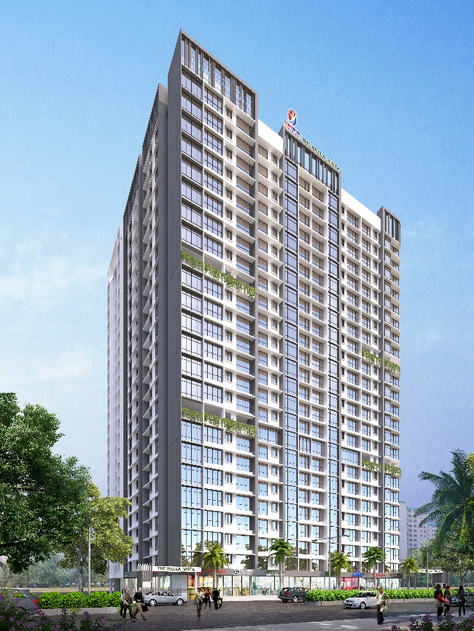
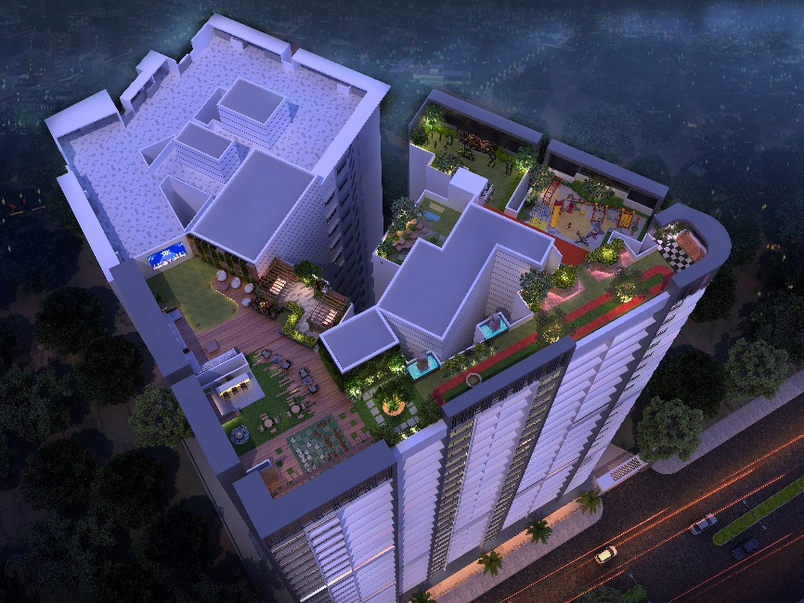
Image 7.
Image 6.

